AI Assistant Lab Assignment-1
Name: M.Jagadeesh
Hall Ticket No: 2303A52290
Assignment:01
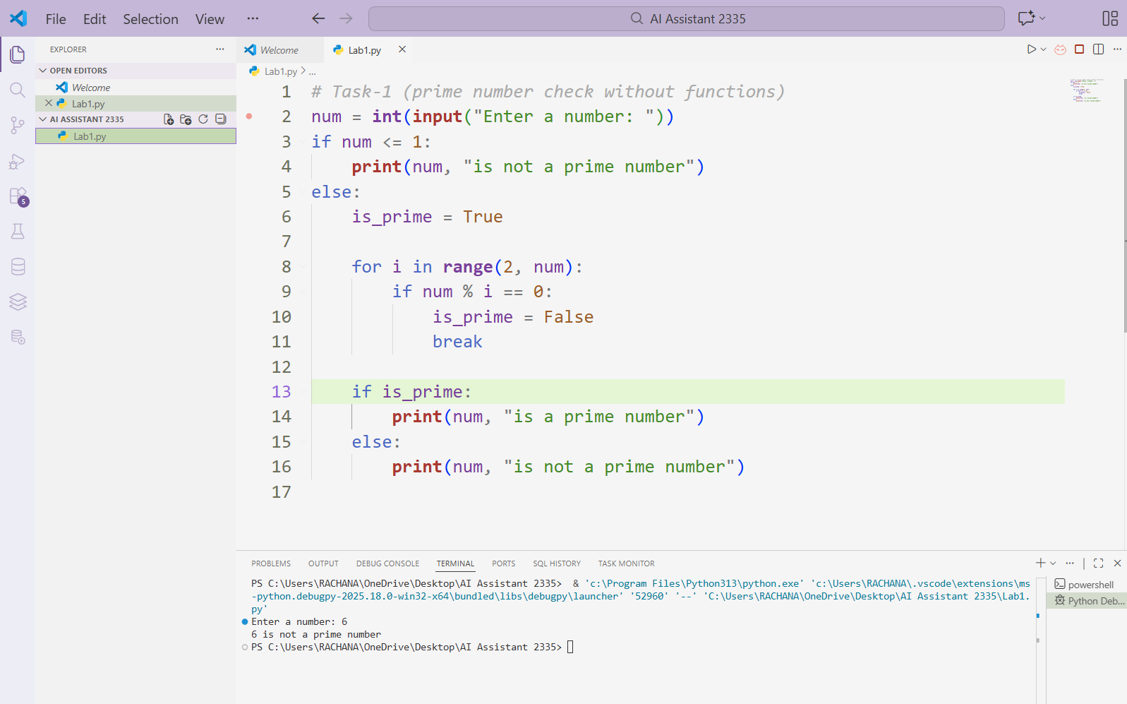
Task1: AI-Generated Logic Without Modularization (Prime Number Check Without Functions write a python code to check the given number is prime or not without using functions
Observation:
The program verifies whether the entered number is a prime number by executing all the required logic directly in the main program flow, without relying on user-defined functions. It takes input from the user and applies looping and decision-making statements to check for possible factors. This method keeps the program straightforward and easy to follow, making it ideal for beginners who are being introduced to basic control structures. Although the code is not modular and cannot be easily reused or extended, it clearly illustrates the fundamental concept of prime number checking. Hence, the program effectively serves its purpose as a learning-oriented implementation.

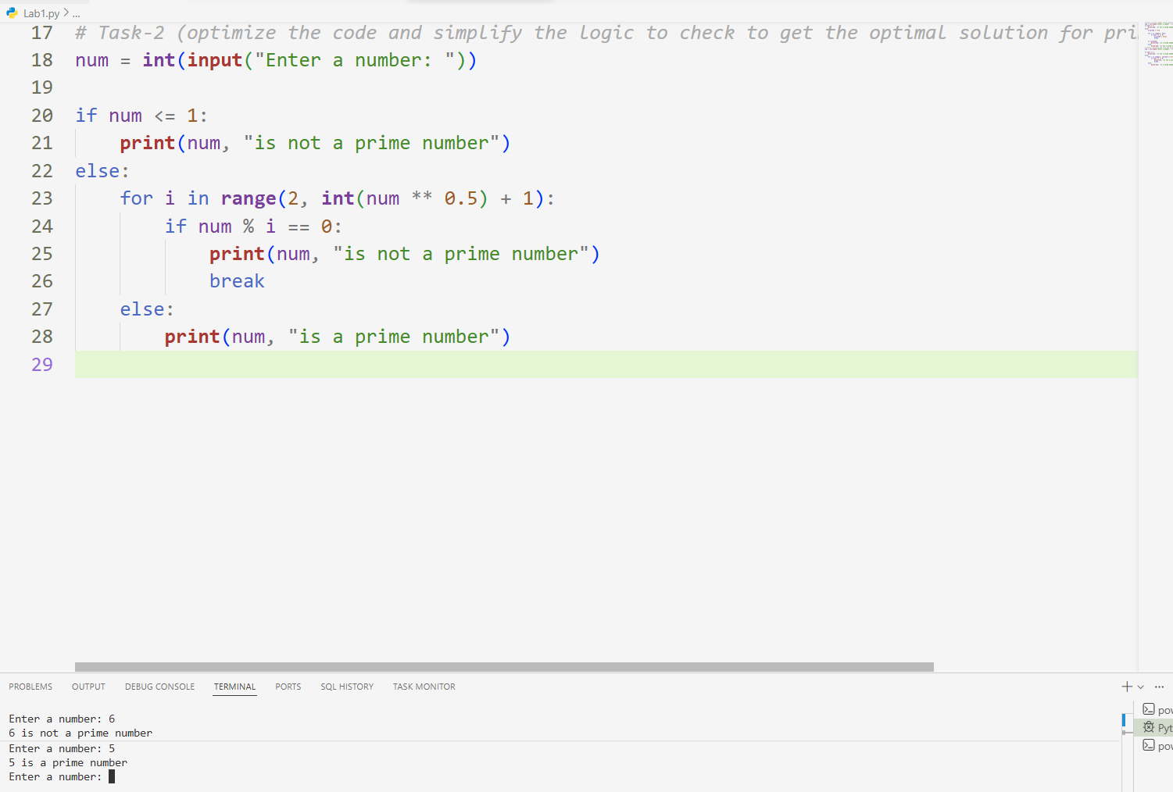
Task2: Efficiency & Logic Optimization (Cleanup) optimize the code and simplify the logic to check to get the optimal solution for prime number checking

Observations: The original code checks divisibility from 2 to num-1, resulting in O(n) time complexity, which is inefficient for large numbers. The optimized version reduces unnecessary iterations by checking divisors only up to the square root of the number, since a larger factor would have a corresponding smaller factor already checked. This reduces the time complexity to O(√n). Early termination using break further improves performance. Additionally, clearer variable names and simplified logic enhance readability and maintainability
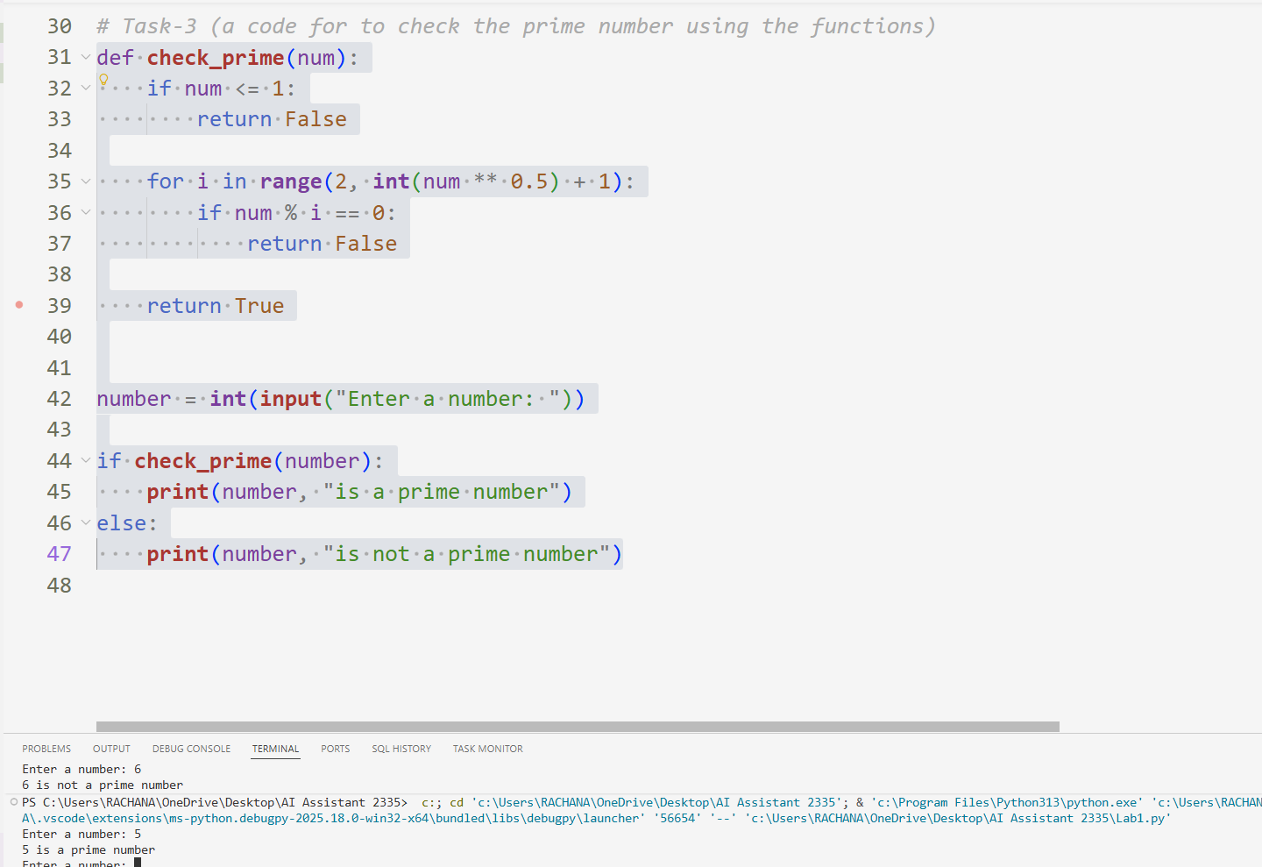
Task 3: Prime Number Check Using Functions (Modular Design)

Observation:
The program determines whether a given number is prime by separating the core logic into a user-defined function. This functional approach enhances code clarity and promotes reusability, allowing the same logic to be applied in multiple contexts without modification. By limiting the divisibility check to the square root of the number, the program achieves better efficiency compared to basic methods. Overall, the modular structure supports easier debugging, testing, and future expansion, making it well-suited for structured and learning-oriented programming practices.

Task 4: Comparative Analysis – With vs Without Functions
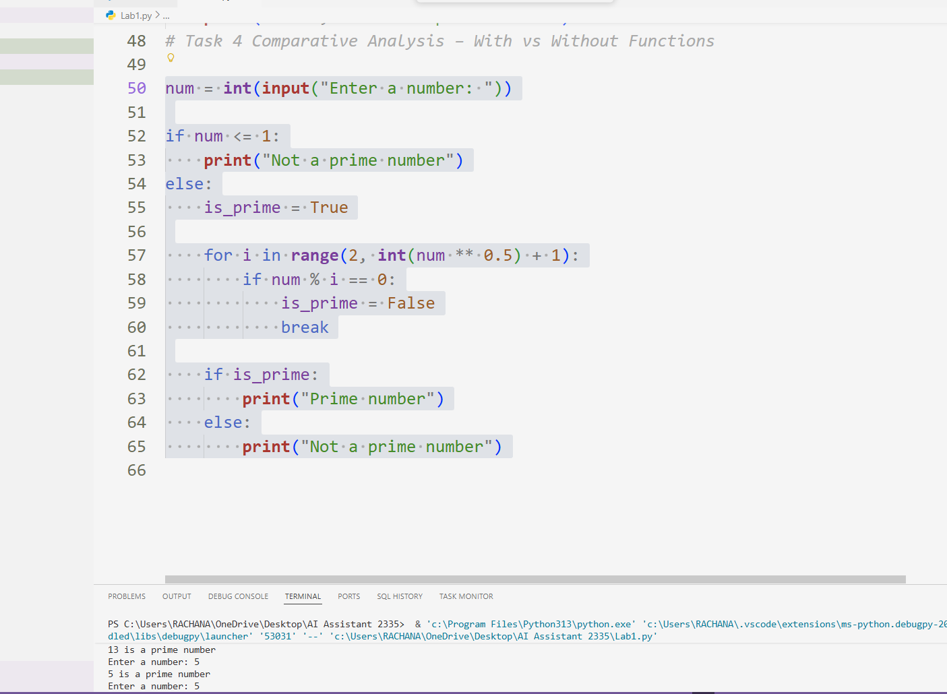

Observation:
The program checks whether a given number is prime by applying an optimized logical approach within the main program, without using any user-defined functions. It takes user input and verifies divisibility only up to the square root of the number, which improves efficiency compared to basic methods. A boolean variable is used to track the primality status, allowing the program to terminate early when a divisor is found. This structure keeps the code simple, readable, and efficient, making it suitable for learning logical optimization in prime number validation.

Task -5: AI-Generated Iterative vs Recursive Fibonacci Approaches (Different Algorithmic Approaches to Prime Checking
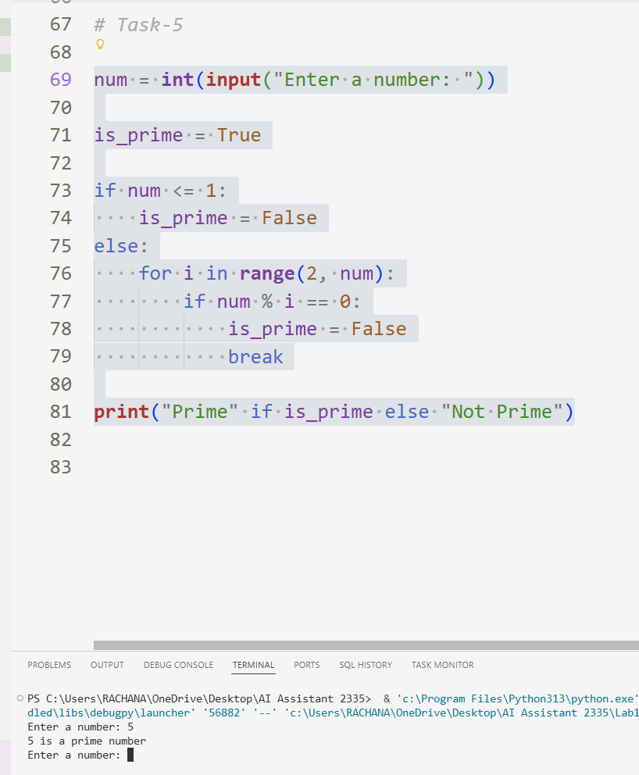
Observation:
The program determines whether a given number is prime by using an iterative loop and conditional checks within the main program. A boolean variable is employed to maintain the primality status and is updated when a factor is detected. The loop terminates early using a break statement, preventing unnecessary comparisons. This approach clearly demonstrates iterative logic and decision-making, making it effective for understanding fundamental prime number validation concepts.

